**Write python programs to understand**

**a) Creating User-defined modules/packages and import them in a program.**

**b) Python program to illustrate the concept of threading importing the threading module.**

**c) Creating a menu driven application which should cover all the built-in exceptions in python.**

**A) math module :**

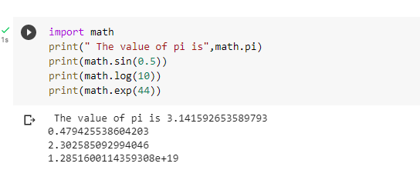

**B) os module :**

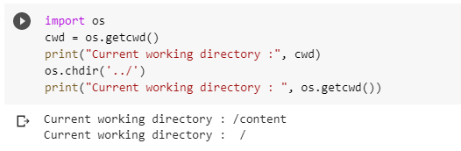

**C) sys module:**

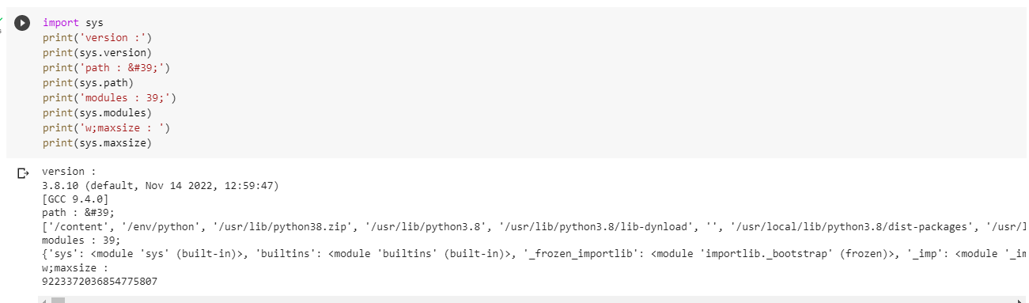

**D) random module :**

**Program:**

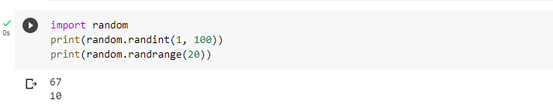

**E) regular expression module :**

**Program:**

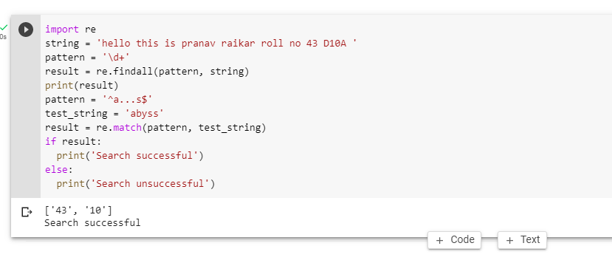

**F)Threading module:**

**Program:**

